**Pivot Table Applications in Excel:**  
Pivot table application in Excel 2010 helps in data analysis.  
  
Here is an example of a company’s sales data based on Sales Representatives, customer, sales, and region. Each row represents a sales transaction. Each column is a field.

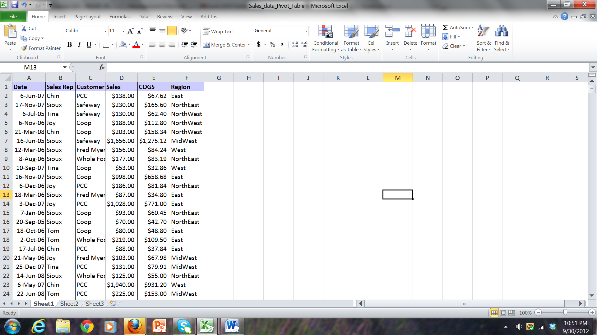

We can use pivot tables and pivot charts in Excel 2010 to obtain summary data from the raw transaction data.

For example, we can get the sum of sales for each sales rep tabulated on the basis of customers etc.

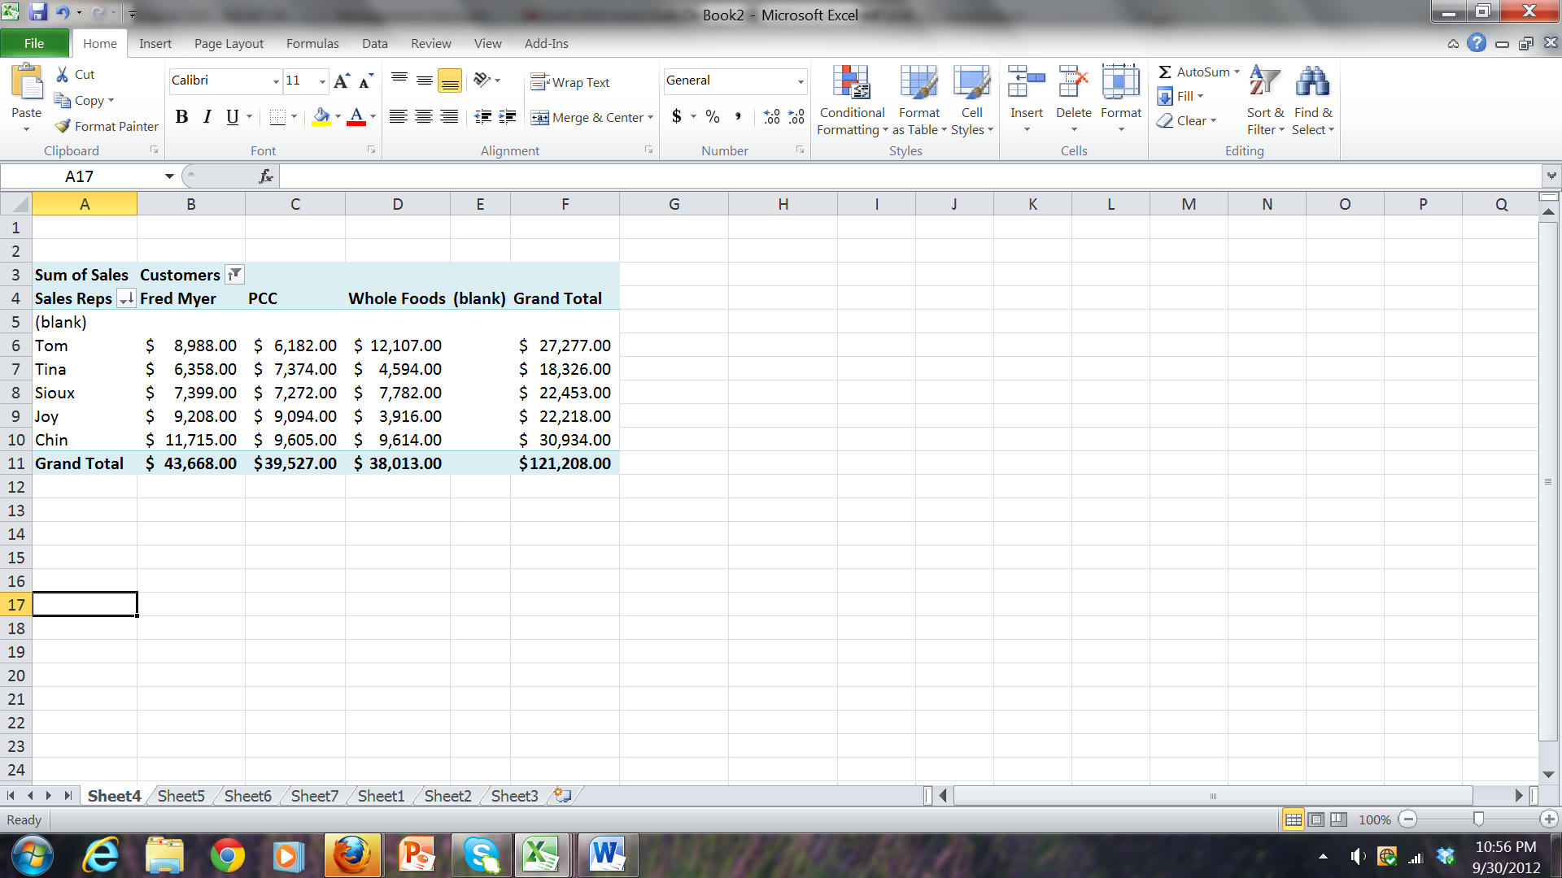

We can also quickly obtain some basic statistical analysis of the data:  
  
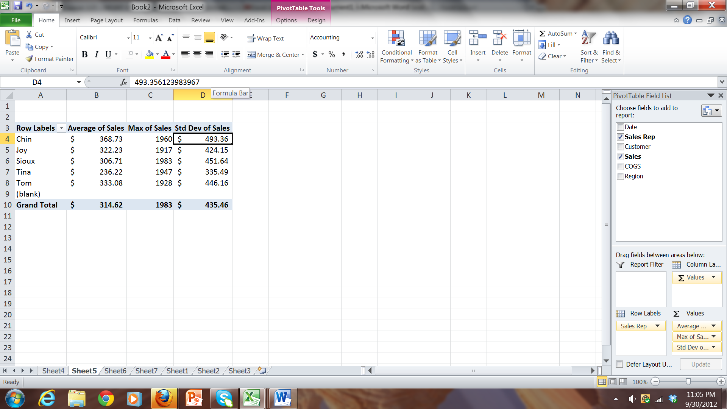

We can also obtain pivot table and pivot chart to understand large data analytics in graphical formats.

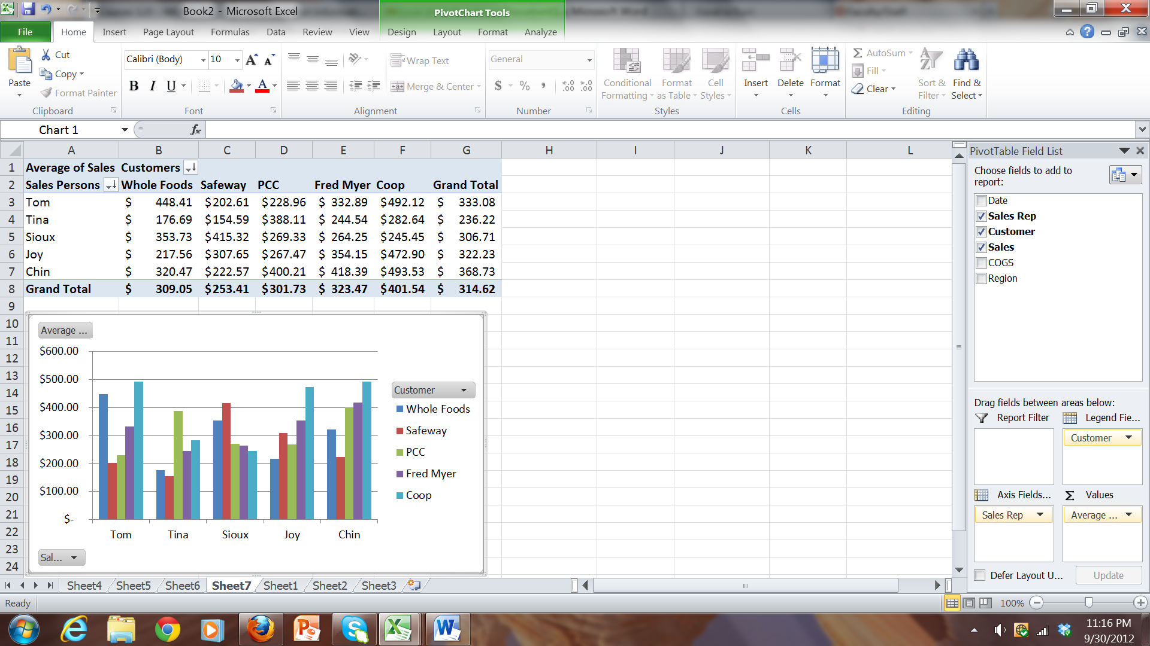

For large data analysis pivot table is critical.

You can sort on rows and columns within pivot tables.

You can switch rows and columns. You can even create a nested row with column data:

